Chapter 1

INTRODUCTION

Background of the Study

The current age of digital transformation, with technologies built for the web, has opened numerous opportunities for organizations, including churches and other religious-based organizations, to manage their records more effectively (Teologice et al., 2026). This is of vital importance for a church that sponsors children, as accurate and proper storage and retrieval of child information are necessary to ensure that a sponsored child receives the care and support they deserve and to ensure the organization is accountable (Eunice Karambu Makathimo, 2022). However, it remains for technology and innovation to allow churches to utilize these amazing possibilities. Combining web-based tools with secure identification methods, such as QR codes, allows churches to move beyond their paper records and towards the future, and is beneficial for monitoring children in the program as well as regular church members (Lerner, 2017).
For a church or organization that cares for a sponsored child, it is vital to have a way to keep and track each child's records accurately and in an organized way. However, at present, most churches use an outdated manual record-keeping method, and many records are lost or not filed correctly (Lhouel Canoy Retobes et al., 2025). Vital records such as attendance logs, information about sponsored children, donations made, developmental growth, and letters are among the records that become misplaced, outdated, or unavailable (Kaell, 2022). This type of central Database is also susceptible to a security breach, which can lead to a child's sensitive information being leaked to the wrong individual (Kishore Gudepu & Sai Jaladi, 2022). With the increasing adoption of digital transformation in churches, it is clear that religious organizations must adopt current technologies to support this crucial part of the ministry.
Even with all the modern automated technology systems out there for industries such as medicine and education, there is still a need for an affordable church-centered technology for the use of monitoring sponsored children. Other systems lack necessary capabilities, such as predictive analytics to identify at-risk children, security to protect minor children's data with a Level 3 encryption standard, and simple user interfaces to guide untrained volunteers (Akoh Atadoga et al., 2024). Furthermore, none of the systems on the market offer the unique feature of integrating QR-based secure digital identification with Level 3 encryption for a sponsored child and church member tracking system.
The researcher proposes a web-based sponsored child and church member identification and monitoring system that utilizes QR-based secure digital identification coupled with the highest encryption standard known today, Level 3. A digital ID in the form of a QR code will be distributed to all participants. With this ID, each authorized staff member will be able to view an individual's entire profile and record via the encrypted web service. This system will have an up-to-date encryption protocol that meets Level 3 standards, with AES-256 encrypting the Database and TLS 1.3 encrypting data in transit to prevent security breaches. Information for church staff will be easily retrievable from a single central place, including attendance, sponsor records, donation history, developmental growth, letters, and participation records, with role-based permissions for access to all data. In return, it will help the Free Methodist Church in Trento track sponsored children more efficiently, reduce paper errors, and become more aware when making decisions for the program (Eunice Karambu Makathimo, 2022)

Statement of the Problem

The existing system for monitoring the sponsored children and churchgoers at the Free Methodist Church in Trento is hampered by limitations in accuracy, efficiency, data storage, and data security. This research attempts to solve the following issues:
- Late tracking of attendance and records retrieval (inefficiency) – Since attendance and records have been paper-based and time-consuming to retrieve any profile, attendance records, sponsor data, donation financial records, status reports, and submitting letters, the church staff is incapable of recalling these instantly(Matasio, 2017).
- Record loss, errors in the data, and lack of data updating; potential data security breaches (data risks) – Vital information could be misplaced or lost and not properly updated because of inadequate centralized management, and real-time data updating is impossible; protection of the child information against unauthorized access in the manual method is lacking(Mubeen et al., 2022).
- Lack of automatic attendance tracking and prediction capabilities. There is currently no system in place to automatically track each church member's attendance and provide predictive analytics that enable church members to anticipate attendance, identify sponsored children at risk, and support objective, data-driven decisions for church improvement programs (Ishaq & Bibi, n.d.).
- Not having a suitable, affordable and secure church technology solution - Whilst other business sector fields do have automated data security systems there does not seem to exist a cheap web based monitoring solution that would meet the operational, financial and privacy requirements of a local church; one that would provide QR based security digital identification, level 3 encryption and provide predicted attendance statistics for sponsored children and steady regular members of the congregation(Campbell, 2023).
The solutions to these problems would aid in monitoring efficiency, reduce hand-made errors, and improve record-keeping and the integrity, security, and privacy of children's information. It. They would also aid in making statistical predictions.

Objectives of the Study

The study aims to implement a web-based automated system that uses secure QR-based digital identification to track children's participation more precisely, ensure the highest level of data privacy, and improve resource allocation for the Free Methodist Church-sponsored children’s programs in Trento. More concretely, it is trying to:
- Design a Web-based Monitoring System for Sponsored Children and Churchgoers with Predictive Analytics that automates check-ins to avoid human or proxy errors and employs secure, unique QR-coded identifiers for every participating child.
- Develop a system to monitor and track each child’s profile, including their attendance status, sponsorship updates, gifts received, letters sent or received, activities attended, and physical metrics such as Height and weight, to enable efficient child monitoring and report generation.
- Implement the system to ensure the maximum protection of all sensitive identifying and personal data of any minor included, at level 3 of security and multi-layered authorization mechanisms. This includes the AES-256 algorithm for data-at-rest encryption, TLS 1.3 for data in transit, a hardware-based storage mechanism for encryption keys, if possible, and carefully designed role-based access and authentication.
- Evaluate the implemented system against the International Organization for Standardization ISO/IEC 25010 standard criteria adapted for a cloud web application context for usability, efficiency, reliability, security performance, functional suitability, and maintainability

Significance of the Study

This study would be useful not only to church administrators, sponsored children, and churchgoers, but also to future researchers.
- Church administrators would find the system useful, as it helps them monitor participation more quickly and accurately in an orderly fashion. Manual processes would also be reduced, minimizing the risk of error and speeding up operations, thereby making church administration more efficient. All confidential child data would be protected from unauthorized access using Level 3 encryption. This would help the church administrators feel secure about storing and retrieving all the children's data.
- Sponsored children and churchgoers would also find the system very fair and reliable, as their participation would be recorded accurately, with minimal chance of error, and without their personal data being easily accessible to malicious users. Personal data would be kept private and safe using level 3 encryption protocols. The system would also help identify those who may need assistance by analyzing their participation patterns.
- Future researchers could use this study as a basis for creating a similar system or further improving it. They would also be able to learn from the use of level 3 encryption standards in a church-based system.

Scope and Delimitation of the Study
Scope
Admin / System Users:
- Can register and encode sponsored children and churchgoers with unique digital identifiers.
- Can automate check-in/check-out processes using secure, encrypted digital identification methods.
- Can generate real-time attendance reports and participation summaries.
- Can view predictive analytics dashboards showing participation trends and children at risk of dropping out.
- Can configure and enforce Level 3 encryption settings and access control rules to protect minors' personal data, including AES-256 encryption for stored data and TLS 1.3 for data transmission.
System Focus:
    - QR-based Identification: Use of unique, secure identifiers for contactless and accurate identification of participants.
    - Level 3 Encryption: Implementation of AES-256 encryption for data at rest, TLS 1.3 for data in transit, hardware-based key protection where applicable, and role-based access control with multi-factor authentication readiness.
    - Predictive Analytics: Analysis of historical participation patterns to forecast future involvement and identify dropout risk.
    - Evaluation Metrics: Comparison with traditional paper-based record-keeping in terms of:
    - Data accuracy (elimination of manual/proxy errors)
    - Speed of reporting (real-time vs. manual consolidation)
    - User experience (ease of use for volunteers/staff)
    - Security effectiveness (data protection compliance)

Delimitation (Exclusions / Constraints)

Not Included:
- Cannot use GPS, biometrics (fingerprint/face), RFID, or mobile-based check-ins as primary identification methods.
- Cannot analyze non-attendance related factors (e.g., academic performance, household income) for the predictive model.
- Cannot integrate with external church management systems (e.g., giving databases, membership portals).
- Cannot include automated notification systems (e.g., email or SMS alerts).
- Cannot include physical security features as part of the study.
- Cannot include the implementation of encryption key management infrastructure beyond the basic Level 3 requirements.

Constraints/Limitations:
- Limited to participants (sponsored children and church goers) who are issued and consistently carry their assigned digital identification credentials (e.g., cards or tags).
- Predictive accuracy is dependent on sufficient historical participation data.
- The study assumes stable electrical power and basic internet connectivity for the digital identification readers and server to maintain encrypted data transmission.
- User acceptance testing is limited to church staff and volunteers, not external IT or security experts.
- The system is tested only at one church location (Free Methodist Church in Trento) and may not generalize to other venues.
- Encryption performance may introduce minimal processing latency, which is considered acceptable within the study's efficiency criteria.

Location of the Study: Free Methodist Church in Trento (specifically for programs involving sponsored children and regular church attendees).

Timeframe: The study covers system development, testing, and pilot implementation within one academic/program cycle.

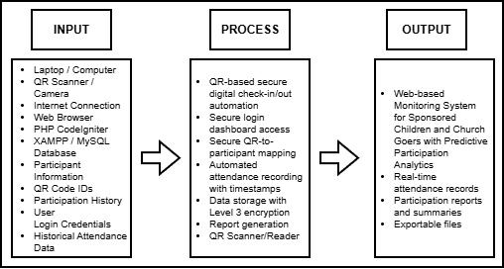

Figure 1. Conceptual Framework of the Study

The study then adopts the framework to explain the process flow of the Web-based Monitoring System for Sponsored Children and Church Goers with Predictive Participation Analytics using the IPO (Input-Process-Output) model as the framework that visualizes the main inputs, processes, and outputs of the system being introduced. It endeavors to establish how, through the combination of QR-based secure digital identification, web-based platform, predictive analytics, and L3 encryption standards will enhance participation monitoring, recording of attendance and database management in the Free Methodist Church Trento, Italy in the endeavor to increase accuracy, efficiency, security, and reliability in the monitoring of sponsored children and church goers by lessening manual inputs and time lapses in record management.

Operational Definition of Terms

Secure Digital Identifier – This is a unique credential generated and assigned to each sponsored child and each churchgoer for touchless, error-free identification at check-in and check-out. In this study, the Secure Digital Identifier replaces manual entry, errors, and proxy entry.
Web-based Monitoring Platform – This platform can be accessed via a web browser (over the Internet or local intranet) by church administrators, allowing them to display, control, and analyze attendance data in real time without requiring any software to be installed on every PC. Level 3 encryption procedures will protect data sent or received by the platform.
Predictive Participation Analytics – The analysis of past participation records to predict the future attendance habits and profile those that exhibit trends of reducing engagement or long inactivity for proactive intervention.
Level 3 Encryption – The definition of a complete encryption policy; that is, AES-256 for data at rest, TLS 1.3 for data in transit, and hardware-based key protection when applicable. In this research, all Personally Identifiable Information (PII) of minors is stored in the Database with Level 3 encryption to ensure confidentiality and integrity in the event of a security breach.
AES-256 Encryption – a sophisticated data encryption mechanism that uses a 256-bit key. AES-256 encryption is one component of the Level 3 encryption used in the study, safeguarding the PII of children stored in the system database in the event of a data breach or database theft.
TLS 1.3 (Transport Layer Security 1.3) is the latest security protocol used for data transmission between the web-based platform and the client’s browser. In the context of the study, TLS 1.3 safeguards the transmission of check-in, participant record, and report data against potential interception.
QR Code (Quick Response Code) – a two-dimensional barcode that encodes identification information. In this system, each Participant is issued a card with a QR code, which is scanned upon entering the locations to log their visit.
QR-Based Secure Digital Identifier Credential – an object that holds a unique, encoded participant identifier, such as a token or a QR-coded card. The system here uses passive, battery-less QR cards due to their low cost, robustness, and reusability.
Participation Log – A database file that stores the Participant's identification number, check-in/out time, the event, and any risk indicators from the predictive algorithm. Every participation log is encrypted with AES-256.
User Experience (UX) – The overall satisfaction, ease of use, and efficiency experienced by the church staff and volunteers using the web-based monitoring system. UX is determined by measuring the time to complete a specific task, surveying users, and comparing it with paper-based tracking.
Role-Based Access Control (RBAC) – A control that limits access to the application based on the roles that an individual holds within the church structure. In this research, RBAC prevents granting access to view, edit/export certain information, such as child data. RBAC also acts as a means of accessing Level 3 encryption.

Chapter 2

REVIEW RELATED LITERATURE, STUDIES, AND SYSTEMS

Secure Identification Monitoring Systems

As seen in recent studies, QR-based secure digital identification technology in monitoring systems speeds up data capture and processing times, reducing manual errors. The data is collected instantly when a reader scans a QR code on a secure card or tag. Supporting this statement is the related literature. (Benique, 2025)reported a 100% read accuracy, a response time of 0.03 seconds, 94% of cost reduction, and a saving of 50 minutes of administrative time per day using the automated school attendance control system, using QR-based secure digital identification with Raspberry Pi and Arduino. (Suhardi, 2024) used a QR-based secure digital ID student monitoring system and revealed that the average time of QR code detection was 1.159 seconds, thus proving that identification can be automated rather than manual. A school children's safety system based on QR-based secure digital identification and IoT proposed that parents would receive a daily message indicating the child's boarding and alighting times and location via GPS (Bhatt et al., 2024). A low-cost, low-scale IoT-enabled Smart Children Tracking system using QR scanning, facial recognition, and map services was developed. An article on the use of digital ID in religious institutions concludes that QR-based secure ID technology is most appropriate and efficient for tracking congregant attendance, inventorying religious relics, and managing security and donations in a church (Kusuma & Utami, 2025). Most organizations use QR-based secure digital identification technology for its fast, error-free logging of attendance and user identification. In traditional paper-based attendance management systems, organizations often receive erroneous data due to misplaced documents or proxy reports. For these reasons, organizations have opted for automated systems, as evidenced by the research above. QR-based secure digital identification has become one of the most popular technological solutions due to its contactless use and real-time tracking capabilities. Moreover, in monitoring systems, QR-based secure digital cards could be used to identify people, providing complete participant information immediately after scanning the card's QR code, thereby improving system effectiveness and reducing manual search time.

Web Based Monitoring Systems

Organizations and churches use sponsored child monitoring systems to ensure their children receive adequate support and oversight during their participation. Paper records, which are traditionally used in organizations and churches, can lead to inaccurate records, delayed updates, and information loss. The newer child monitoring systems have individual child profiles that include personal information, attendance, donor information, and status updates for sponsored children (Mahlan et al., 2025).
One computer software program is designed to automate 90% of child sponsorship activities, including donor management, child tracking, financial reporting, and communication tools (Kaell, 2022). There are many software systems available that track children’s development, the services they receive, and whether the program is effectively reaching its objectives, and that offer encryption and login controls (Song et al., 2018). An investigation was conducted into record-keeping practices in church archives; there was a significant positive association between the use of electronic documents and increased security, retention, and accessibility. The Report on the trends in child sponsorship shows that it is becoming increasingly community-driven, sustainable, and technologically savvy, with a system that improves communication and data protection for sponsors (Eunice Karambu Makathimo, 2022).
These systems help organizations manage records and communicate with sponsors. Some monitoring systems can provide details such as the child's growth rate, weight, and participation history, as well as letters sent and received. This would enable the organization to understand better the sponsored child's state and participation (Brad Watson, n.d.).

Sponsored Child Monitoring Systems

Organizations and churches use sponsored child monitoring systems to ensure their children receive adequate support and oversight during their participation. Paper records, which are traditionally used in organizations and churches, can lead to inaccurate records, delayed updates, and information loss. The newer child monitoring systems have individual child profiles that include personal information, attendance, donor information, and status updates for sponsored children (Mahlan et al., 2025).
One computer software program is designed to automate 90% of child sponsorship activities, including donor management, child tracking, financial reporting, and communication tools (Kaell, 2022). There are many software systems available that track children’s development, the services they receive, and whether the program is effectively reaching its objectives, and that offer encryption and login controls (Song et al., 2018). An investigation was conducted into record-keeping practices in church archives; there was a significant positive association between the use of electronic documents and increased security, retention, and accessibility. The Report on the trends in child sponsorship shows that it is becoming increasingly community-driven, sustainable, and technologically savvy, with a system that improves communication and data protection for sponsors (Eunice Karambu Makathimo, 2022).
These systems help organizations manage records and communicate with sponsors. Some monitoring systems can provide details such as the child's growth rate, weight, and participation history, as well as letters sent and received. This would enable the organization to understand better the sponsored child's state and participation (Brad Watson, n.d.).

Predictive Participation Analytics

Predictive analysis is the use of past data to identify patterns that predict future actions (research shows that predictive systems rely on historical data for optimal decision-making and monitoring). With secure digital identification that can securely scan and collect attendance information using QR codes, predictive analytics are best utilized for attendance monitoring.
Forty-two machine learning models were built to predict participation, of which LightGBM performed best with a prediction accuracy of.838, precision of .783, recall of .967, and an F1 score of.865; using education level and physical activity as the main factors (Abukader et al., 2025). A church analytics study showed how churches could use historical data from their QR-coded check-ins to predict potential attendance slumps and prepare outreach campaigns targeting those at risk of leaving (Joy Awad, 2023). Analysis xof the use of data management and classification in religious institutions suggests that these practices help overcome inconsistencies in records and enable grouping by specific criteria useful for strategic planning (Wiratama & Desanti, 2021).
Participation analytics can identify members who are slipping away from activities and those at risk of disengaging (Joy Awad, 2023). Through attendance and participation history, collected via the scanning of the QR codes, an encrypted report can be generated that would help the staff and employees of an organization perform timely interventions, and maintain child confidentiality through role-based access control (RBAC) Regarding the monitoring process, it is improved with predictive analytics since administrators can now plan based on available data and not assumptions, with all historical data kept secure using AES-256 encryption and results passed using TLS 1.3(NIST.SP, 2020), and helps organization make better use of their resources due to patterns and trends found within logged participation records.

Data Security and Records Management

It is also imperative to ensure data security, especially the personal information of children and sponsors (Kishore Gudepu & Sai Jaladi, 2022). Data security and access controls are necessary when the system handles personal information to protect confidential information from unauthorized access. Level 3 encryption standards are currently used by the monitoring system, which consists of AES-256 encryption for data at rest, TLS 1.3 for data in transit, hardware-based key protection for securing access and personal data, specifically for the acquisition of attendance data by using QR code scanning, alongside Role-Based Access Controls (RBAC) (Akoh Atadoga et al., 2024)
Information security risk management in records-keeping may involve encryption, access controls, and regular audits, as stated by a government agency. The global church security report found that cyberattacks targeting church donation systems increased by 22% due to weak authentication, while secure, well-encrypted solutions will keep donors' data safe (NIST.CSWP, 2024). One of the case studies showed that a Protestant church used a digital solution with regular backups, multi-tier firewalls, and role-based access control for data, and thus received a security award (NIST.SP, 2020). The church management platform used an SSL certificate (equivalent to TLS 1.3), a hardened firewall, CCTV, and biometrics to control access to information, as well as an encrypted Database, thereby protecting church members' data (Adjin-Tettey & Kwofie, 2025).
The presence of such security measures will protect the integrity and confidentiality of sensitive data captured via QR-based check-ins, thereby allowing only authorized persons to access it (Kusuma & Utami, 2025). Moreover, the measures help ensure reliable records management by avoiding issues such as data loss, corruption, or inaccuracies caused by poor encoding. With Level 3 encryption, all encrypted personal data stored in the Database will be illegible even if the QR code identifiers are linked, without the correct cryptographic key (Akoh Atadoga et al., 2024). All QR codes transmitted from the check-in point to the central server would be encrypted using TLS 1.3 and thus would be unable to be intercepted or tampered with.

Related Systems and Church Management Platforms

Several organizations are now using QR-based secure digital identification and Web-based systems for identification and tracking (Lerner, 2017). Existing systems are typically implemented to track participant attendance using QR code scanning (Kusuma & Utami, 2025). However, the implemented system is only for basic attendance monitoring and child profile management, and strong encryption cannot be implemented, as no features are provided for it.
The GDPR-compliant church management platform lets members control their own visibility information through the member portal. The cloud-based church management and accounting software automates church finances, administration, and operation (Wiratama & Desanti, 2021). It integrates with affordable QR-based secure digital identification devices to track members. All-in-one church management software tracks church members, attendance, events, communication, donations, accounting, and worship planning on a single scalable platform (Simanjuntak & Porman Malau, 2026). A centralized church management information system assists church leaders in strategizing and making efficient decisions based on centralized data. Moreover, an international meeting was established to establish standards for handling records in structured data environments.
This proposed system is different from existing systems by integrating QR-based secure digital identification, Web-based monitoring, child profile management, sponsor information, participation tracking, Level 3 encryption (AES-256 and TLS 1.3), and predictive analysis (LightGBM) into a single platform (Mahlan et al., 2025). Instant access to a complete child profile is provided by scanning the Participant's QR code, and strong encryption safeguards records at rest (AES-256) and during transmission (TLS 1.3), making monitoring efficient, reducing errors, and maintaining privacy. The integrated system for information on sponsored children in the Free Methodist Church of Trento provides organized data management (Eunice Karambu Makathimo, 2022).

Gap Analysis

Table 1: Analysis Matrix
Features / Related Studies and Systems | QR-Based Identification | Web-Based Monitoring | Sponsored Child Monitoring | Predictive Analytics | AES-256 & TLS 1.3 Security
Secure Identification Monitoring Systems | ✓ | ✗ | ✗ | ✗ | ✗
Web-Based Monitoring Systems | ✗ | ✓ | ✗ | ✗ | ✗
Sponsored Child Monitoring Systems | ✗ | ✗ | ✓ | ✗ | Partial
Predictive Participation Analytics Systems | ✗ | Partial | ✗ | ✓ | ✗
Data Security and Records Management Systems | ✗ | Partial | ✗ | ✗ | ✓
Church Management Platforms | Partial | ✓ | Partial | ✗ | Partial
Web-Based Monitoring System for Sponsored Children and Church Goers Using Secure Digital Identification with Predictive Participation Analytics | ✓ | ✓ | ✓ | ✓ | ✓

Chapter 3

METHODOLOGY

For the study, a developmental design will be used in the design, conceptualization, and testing of the web-based, QR-based secure digital identification monitoring system for church-sponsored children’s programs and everyday churchgoers, using Level 3 encryption standards (AES-256 for data at rest and TLS 1.3 for data in transit) 26. The descriptive part will assess how participation is currently tracked and documented, as well as church program monitoring procedures, including identification of problems with the current manual, paper-based check-ins, the lack of real-time reporting, proxy attendance, and the identification of children in at-risk groups for dropping out. Developmental design will be used, as this study focuses on developing new technology to meet specific needs rather than evaluating an already developed product. This part of the study also provides the necessary benchmark for comparison with the proposed paper-based system, as stated above.

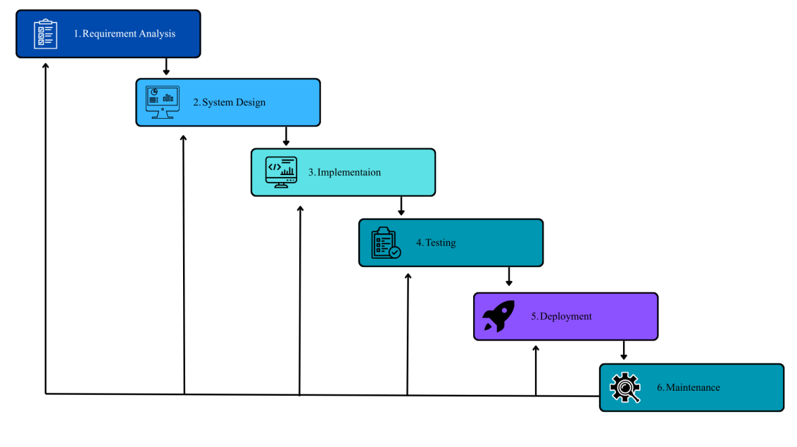
Research Model
Figure 2. Iterative Waterfall Model
The Iterative Waterfall Model used in the proposed system development is displayed above, comprising six consecutive stages: Requirements Analysis, System Design, Implementation (Coding), Testing, Deployment, and Maintenance. The process development follows a systematic waterfall model, where each stage is completed before proceeding to the next, ensuring a methodical plan, design, and implementation. Unlike the waterfall model, the system includes iterative paths in which the process is revised based on results from User Acceptance Testing (UAT) and stakeholder feedback. The feedback arrows from the Testing stage to both the Requirements Analysis and System Design stages indicate that problems, new functionality, or modifications to the requirements can be incorporated without restarting the process. The link from the Deployment to Maintenance stage shows the constant upkeep, updates, and performance optimization of the implemented system.

Software Development Model
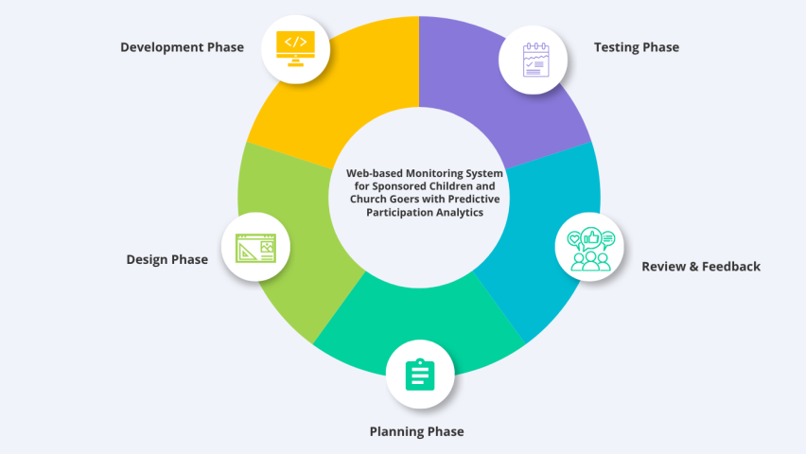
Figure 3. Agile Development Model

The Web-based Monitoring system for Sponsored Children and Church Goers with Predictive participation analytics follows an iterative, incremental development approach based on Agile methodology to adapt to changing requirements efficiently. Its 5-stage development-planning, designing, developing, testing, review and feedback is performed in short and useful sprints, which provides flexibility for incremental refinement of critical components-QR-based automated check-in/check-out through a secure digital system, real-time dashboards for participation, predictive models to identify risk of attrition (LightGBM), level 3 encrypted data at rest (AES-256 and at transport (TLS 1.3 and RBAC) etc., through direct feedback of end users namely church administrators, program coordinators and volunteers.

Requirements Analysis
User Requirements
- Log in and View Dashboard – Church administrators, program coordinators, and authorized volunteers can securely log in and view their dashboard, which shows participation summaries, alerts, and system tools.
- Register and Encode Participants with QR-Based Secure Digital IDs – Administrators can register sponsored children and church goers, assign unique QR-based secure digital identifiers (encoded cards with QR codes), and update participant information (name, ID, program affiliation).
- Automated QR-Based Secure Digital Check-in/out – Participants scan their secure digital card with a QR code at designated points of entry for their respective events within the church, which in turn logs the timestamp, participant ID, and the event taking place.
- View Real-time Participation Reports – Permitted users may access the real-time attendance summary, including daily, weekly, and monthly reports, total numbers, attendance rates, attendance histories, etc.
- Access Predictive Analytics Dashboard – Church leaders can see dashboards that visualize participation trends, predicted attendance trends, and sponsored children predicted to be high, medium, or low risk of dropping out of the program.
- Generate and Download Reports – Users can generate and download PDF or CSV reports, like a weekly participation summary, an at-risk child list, an activity log, etc.
- Encrypt and Protect Minors’ Data – The PII of sponsored children is secure and encrypted using Level 3 security (AES-256 for data at rest and TLS 1.3 for data in transit).

Functional Requirements
- User Authentication – Church administrators, program coordinators, volunteers, and viewers can log in to the system with encrypted credentials. The system authenticates each user's identity based on Role-Based Access Control (RBAC) to determine which levels of participant information, reports, and system configuration are accessible. MFA is enabled for the administrative account.
- QR-Based Secure Digital Participant Registration and ID Assignment – Allowed administrators to register sponsored children and regular church members into the system, and issue a secured digital QR card with their identity details (name, ID, associated program) into an AES-256 encrypted database.
- Automated QR-Based Secure Digital Check-in/out – Participants present the secure digital QR card to the readers installed at the church entrances. The system instantly captures and records the Participant's ID, event type (e.g., Sunday service, children's ministry), and time with no manual input, and removes the possibility of proxy reporting. QR scan data is transmitted over TLS 1.3.
- Real-time Participation Dashboard – Authorized users can easily find live participation updates by scanning a QR code, including the current attendee list, attendance count, and recently absent attendees. Children and church member participation rates will be updated after each QR scan.
- Predictive Analytics Module – The system is equipped with a predictive analytics module that uses ML algorithms (e.g., LightGBM) to predict future attendance trends and identify children whose attendance rates are declining and/or those with a long period of absence from the program. Each child receives a risk score from 0 to 100, based on their participation history in terms of frequency, regularity, and recency.
- At-risk Child Identification and Reporting – System is capable of generating a list of sponsored children at a certain level of risk of withdrawing from the program, along with risk scores and evidence to assist church leaders in early intervention measures.
- Report Generation (PDF/CSV) – Users can export participation summaries, lists of at-risk children, a full history for a specific participant, and the system audit trail in PDF or CSV. If the user has selected a report that contains sensitive information, the Report can be encrypted with a user-set password.
- Data Encryption and Privacy Protection – All personally identifiable information about minors is encrypted with AES-256 before storage. Data transmitted is encrypted using TLS 1.3, including the QR scan transmissions. The encryption keys are stored in the HSM or a secure key vault. Sensitive data (the name, ID, the QR code identifier, and other personal information about the child) will remain unreadable even if the Database is stolen.
- Audit Trail and Activity Logging – System logs critical user activity, including logins, participant registration, secure digital ID creation with a QR code, check-in/check-out using a QR code, report generation, and data edits, so it is evident and available to any required authority and cannot be tampered with.
- Role-Based Access Control (RBAC) - Only Church Administrators can access all aspects of the system. Program Coordinators have limited access only to their assigned children. Check-in Volunteers only have read-only access to the children’s basic information. System Administrators have security control but no read/write access to the minors’ PII.
Non-Functional Requirements
- Usability – Easy to use by all church staff and volunteers who may not be technically proficient. Includes an intuitive interface with easy menus and very straightforward QR code check-in (1-2 seconds/scan), and simple dashboards that may require an hour or less of training.
- Security – All information (QR scan check-in logs, participant details, and user accounts) must be encrypted. The standard encryption level (3) will be used. AES-256 will be utilized when data is not being transmitted, and TLS 1.3 will be used when data is transmitted. All encryption will use hardware-based keys. Access control for the system must be password-based, with all passwords protected by hashing (using either bcrypt or Argon2). An RBAC (Role-Based Access Control) model should be implemented. There should also be a 15-minute session timeout to prevent unauthorised access to the system and to ensure the confidentiality, integrity, and availability of minors' personal data. Scalability- This must be able to handle a growing number of participants and other QR code scanners. It can scale the Database horizontally.
- Scalability – The system must support an increasing number of participants and accommodate additional QR code scanners as the church expands its programs or adds new entry points. Database design must allow horizontal scaling.
- Performance - QR Code scan to profile average under 2 seconds. Support at least 10 concurrent users. Reports are generated under 5 seconds (i.e., Monthly Report). 95% database queries returned under 500ms.
- Reliability - The system will have 99.5% uptime (excluding scheduled downtime). The system's MTBF will exceed 200 hours. Daily encrypted backups will occur.
- Maintainability -The code will be well-documented. Modularity will be employed to enable easy updates to individual modules, such as Security modules, predictive analysis algorithms, or UI components.
- Compliance - This system will be designed to ensure compliance with all applicable data protection laws governing the collection, storage, use, and processing of a minor's data obtained via the QR Code check-in. This system will be designed to ensure that all L3 encryption requirements outlined in this document are met.
- Availability - All QR code scanners will cache check-in data for up to 4 hours in local storage when no internet is available. Cached data will sync to the main server when the network is restored and will be encrypted at rest (AES-256) and in transit (TLS 1.3).Software Requirements
Table 2: Visual Studio Code Software Requirements
Software Tool | Description
Visual Studio Code | A lightweight, feature-rich code editor by Microsoft. It supports PHP, HTML, CSS, JavaScript, and provides integrated terminal, Git support, and extensions for debugging, code linting, and security scanning.
Table 3: XAMPP Software Requirements
Software Tool | Description
XAMPP | An open-source web server solution stack package that includes Apache, MySQL, PHP, and Perl. It allows local development and testing of the web-based system before deployment to production.
Table 4: Backend Framework Software Requirements
Software Tool | Description
CodeIgniter 4 / Laravel / Node.js | A backend framework that follows the MVC pattern, used to build scalable web applications. For this project, a suitable backend framework is chosen to handle QR code data processing, predictive analytics, Level 3 encryption (AES-256 and TLS 1.3), and database operations. The framework must support encryption libraries, QR code generation libraries, and role-based access control.

Table 5: Bootstrap / CSS Framework Software Requirements
Software Tool | Description
MySQL / PostgreSQL | A relational database management system used to store all system data: participant records, QR code identifiers (encrypted), participation logs, predictive risk scores, user accounts, encryption metadata, and audit trails. PostgreSQL is preferred for its built-in AES-256 encryption support via pgcrypto extension. Works seamlessly with PHP/Python/Node.js backends.
Table 6: Bootstrap / CSS Framework Software Requirements
Software Tool | Description
Bootstrap | A popular front-end CSS framework used to create responsive, mobile-friendly web interfaces for church staff accessing the system on desktops, tablets, or smartphones. Ensures consistent user experience across devices.
Table 7: QR Code Scanner SDK/API Software Requirements
Software Tool | Description
QR Code Scanner SDK / API | The software development kit provided by the QR code scanner manufacturer or open-source library. It enables communication between the QR code scanner (webcam or dedicated scanner) and the system via USB, network, or browser-based API. The SDK must support encrypted data transmission and secure reading of unique QR code identifiers.
Table 8: Web Browser Software Requirements
Software Tool | Description
Google Chrome/Brave Browser | A web browser used for testing and running the system. It provides developer tools to inspect network activity, debug JavaScript, and optimize front-end performance. The browser must support TLS 1.3 for secure connections to the web server and have webcam access for QR code scanning via browser-based APIs.
Table 9: Encryption and Security Software Requirements
Software Tool | Description
OpenSSL / LibreSSL  bcrypt / Argon2  pgcrypto / MySQL Enterprise Encryption | Cryptographic library used to implement TLS 1.3 for data in transit and to generate secure keys for AES-256 encryption. Required for web server configuration and database connection encryption.  Password hashing libraries used to securely store user passwords and passcodes for sponsored children. Passwords and passcodes are hashed with salt before storage; plaintext values are never stored.  Database encryption extensions that provide built-in AES-256 encryption functions for column-level and transparent data encryption (TDE).
Table 10: Predictive Analytics Software Requirements
Software Tool | Description
Python (with scikit-learn, LightGBM, pandas, numpy) | Programming language and libraries used to develop the predictive analytics module. LightGBM is the primary algorithm for forecasting attendance patterns and calculating dropout risk scores. Python scripts are integrated with the main web application via API or scheduled jobs.
Table 11: Version Control Software Requirements
Software Tool | Description
GitHub / GitLab | Version control system used to track code changes, manage collaborative development, and maintain backup of source code. Ensures code integrity and facilitates rollback to previous versions if needed.

Table 12: QR Code Generation Library Software Requirements
Software Tool | Description
PHP QR Code / endroid/qr-code / Python qrcode | Library used to generate unique QR codes for each participant. Each QR code contains an encrypted unique identifier that is printed on secure digital cards and scanned during check-in/out.

Hardware Requirements

Table 13: Desktop/Laptop Computer Hardware Requirements
Hardware Component | Description
Desktop/Laptop Computer | Used to develop, test, and manage the system. Minimum specifications: Intel Core i5 or equivalent, 8-16 GB RAM, 256 GB SSD, USB port, webcam (for QR code scanning), and network connectivity.
Table 14: QR Code Scanner Hardware Requirements
Hardware Component | Description
QR Code Scanner (USB or Wireless) | A dedicated QR code scanner that reads QR codes from secure digital cards. Connects to the computer via USB or Bluetooth. The scanner must support fast reading (<2 seconds per scan) and be durable for repeated use at church entry points. Alternatively, a standard webcam with QR code scanning software can be used.
Table 15: QR Code Secure Digital Cards / Tags Hardware Requirements
Hardware Component | Description
QR Code Secure Digital Cards / Key Fobs | Assigned to each participant (sponsored child or church goer). Each card contains a printed QR code with a unique encrypted identifier that cannot be easily cloned. When scanned by the QR code reader, the identifier is captured and transmitted securely to the system for attendance tracking. Cards are durable, reusable, weather-resistant, and printed on high-quality materials.
Table 16: Check-in Station Computer / Terminal Hardware Requirements
Hardware Component | Description
Check-in Station Terminal | A dedicated computer, laptop, or tablet placed at church entry points for QR code check-in/out processing. Minimum specifications: Intel Celeron or equivalent, 4 GB RAM, 64 GB storage, USB port for QR code scanner (or built-in webcam), network connectivity (Ethernet or Wi-Fi). A touchscreen tablet with a camera may be used as an alternative.
Table 17: Backup Storage Hardware Requirements
Hardware Component | Description
External Storage / Cloud Backup | Used to store encrypted backups of the database and system files. Helps prevent data loss and ensures recovery in case of system failure or hardware issues. Options include external hard drive (AES-256 encrypted), network-attached storage (NAS), or cloud storage service with AES-256 encryption enabled.
Table 18: Network Hardware Requirements
Hardware Component | Description
Network Switch / Router | Provides stable network connectivity between check-in stations, the server, and the internet. Must support at least 1 Gbps throughput for internal traffic and WPA3 encryption for Wi-Fi security.

Table 19: Uninterruptible Power Supply (UPS)
Hardware Component | Description
UPS (Uninterruptible Power Supply) | Provides backup power to check-in stations, QR code scanners, and the server during electrical interruptions. Minimum 15-minute backup time to prevent data loss and ensure system availability during short outages.

Design Phase
Work Breakdown Structure
Table 20: Work Breakdown Structure (WBS) for QR-Based Monitoring System
WBS Code | Task Category | Activities
1.0 | Project Initiation | - Define system goals and objectives (accurate monitoring, predictive analytics, Level 3 data security)  - Conduct background research on church attendance tracking and QR code secure digital identification technology  - Identify gaps in existing paper-based system (proxy reporting, manual errors, lack of analytics, weak security)  - Finalize project title and scope (Free Methodist Church in Trento)  - Create Gantt chart and timeline
2.0 | Requirement Analysis | 2.1. Consult church administrators, program coordinators, and volunteers for system input  2.2. Identify key features: QR code check-in/out, real-time dashboard, predictive analytics, report generation, Level 3 encryption (AES-256 + TLS 1.3), passcode security  2.3. Define functional and non-functional requirements (as documented)  2.4. Document software and hardware requirements (QR code scanners, QR-encoded cards, server, web stack, HSM)
3.0 | System Design | 3.1 Design database schema (ERD) with tables: users, participants, qr_code_ids, check_in_logs, predictive_risk_scores, encryption_metadata, system_logs, passcode_hashes  3.2 Create Data Flow Diagram (DFD) showing QR code scanner → system (TLS 1.3) → encrypted database → dashboard  3.3 Design module flow (Dashboard, QR Code Management, Reports, Predictive Analytics, Security Settings with RBAC, Passcode Verification)  3.4 Design user interface for admin dashboard, passcode entry screen, participation reports, and predictive analytics views  3.5 Create mockups and wireframes
4.0 | System Development | - Set up development environment  - Develop QR code scanner integration module (webcam or dedicated scanner via browser API)  - Develop QR code generation module for printing participant ID cards  - Code automated check-in/out logging with timestamp and participant validation (TLS 1.3 for data transmission)  - Implement passcode verification module for sponsored children accessing sensitive data (bcrypt compare)  - Implement predictive analytics module (LightGBM for attendance trend analysis and dropout risk)  - Create real-time participation dashboard and reporting interface (PDF/CSV export with optional encryption)  - Integrate Level 3 encryption: AES-256 for stored PII, TLS 1.3 for data in transit, and RBAC for access control  - Implement audit trail logging for all system activities
5.0 | Testing Phase | 5.1. Perform unit testing on QR code scanner integration, database write, encryption, passcode verification, and predictive analytics modules  5.2. Conduct integration testing (QR scanner → web server (TLS 1.3) → encrypted database → dashboard)  5.3 Perform security testing: encryption verification, TLS 1.3 compliance, RBAC enforcement, passcode lockout mechanism  5.4 Facilitate User Acceptance Testing (UAT) with church staff and volunteers  5.5 Debug and optimize performance (QR code detection response time, dashboard load speed, encryption overhead, passcode verification speed)  5.6 Document testing reports and results
6.0 | Deployment | 6.1 Configure local server (dedicated PC) or cloud hosting for web-based system with TLS 1.3 certificate  6.2 Install QR code scanners (or webcams) at church entry points and connect to check-in stations  6.3 Generate and print QR code ID cards for all participants (sponsored children and church goers)  6.4 Assign unique passcodes to sponsored children for sensitive data access  6.5 Train church administrators and volunteers on system usage, passcode management, and QR code scanning procedures  6.6 Collect initial user feedback for refinement
7.0 | Evaluation & Documentation | 7.1 Conduct surveys/interviews with actual users (church staff, program coordinators)  7.2 Evaluate system effectiveness: QR scan speed, passcode security, accuracy, user experience vs. paper-based method  7.3 Finalize documentation: User Manual, Technical Specifications (including QR code generation and passcode security), Developer Notes  7.4 Prepare for oral defense and capstone presentation  7.5 Submit completed system and thesis manuscript

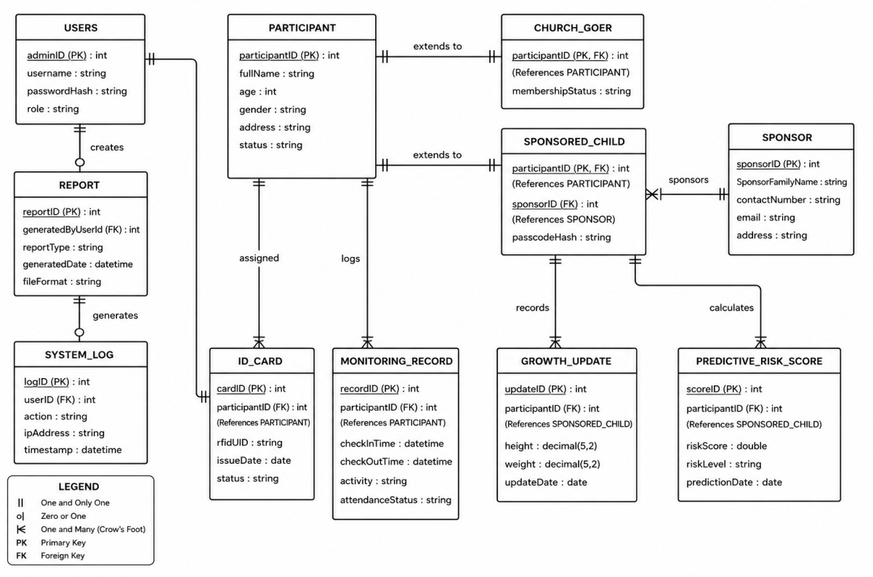
Figure 4. Entity Relationship Diagram (ERD)
This ERD diagram shows the schema of the Web-Based Monitoring System for Sponsored Children and Church Goers with Predictive Participation Analytics. It depicts the relationships among the major components implemented in the system. These components are users, participants, QR-based secure digital IDs, monitoring records, reports, growth updates, predictive risk scores, and system logs. The user controls participant details and user activity using RBAC, and each Participant has a unique, encrypted, QR-based secure digital ID, so the system checks users in and out by scanning the QR codes. The check-in and check-out events in the monitoring record were extracted from QR code scans. The monitoring record data was used to generate reports and predict participation analytics. The system would use AES-256 to encrypt data at rest and TLS 1.3 for all data transfers, including QR scan data. The growth update record stores the growth development status of sponsored children. The predictive risk score stores the participation predictions obtained using the LightGBM algorithm. This can be used to identify children at risk of dropping out of the program. The System Log stores all user actions, enabling easy monitoring by generating tamper-proof records. The ERD is the main reference for the design of the database system, organizing data properly, providing fast access to information, managing the relations between the parts of the system, and applying Level 3 encryption.

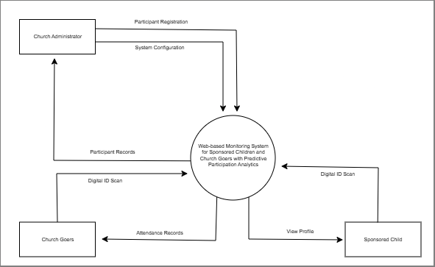

Figure 5. Context Diagram
The Web-Based Monitoring System for Sponsored Children and Church Goers with Predictive Participation Analytics is a centralized system that connects church administrators, church goers, and sponsored children through an automated, QR-based, secure digital identification, attendance monitoring, and profile management process. Digital processes for participant registration, attendance logging, QR code scanning, configuration setup, and profile viewing replace traditional paper-based monitoring. The system promises enhanced data processing speed, higher data accuracy, live attendance and participation monitoring, and robust data security, through AES-256 encryption for stored data and TLS 1.3 for transmitted data.
Church Administrator. The church administrator manages and operates the entire system. System inputs from the Administrator (e.g., Participant registration info and system settings) provide data storage and participant management, and system outputs from the Administrator (e.g., Participant records, attendance records, system-managed data) are used for monitoring attendance and assessing participation. RBAC is applied to ensure that the system user can only access the children's information obtained through the scanning process.
Church Goers. When churchgoers want to check in to the church for attendance, their QR code (on a plastic/electronic card) is scanned by the system. It is the system input. After the user is identified and the recorded data is captured, the scanned code information, read as an encrypted unique identifier, passes through a TLS 1.3-secured channel, authenticates the user, and then records their attendance in real time. In this way, the user can check attendance efficiently, conveniently, and accurately.
Sponsored Child. Similar to churchgoers, the attendance of sponsored children is verified by scanning their QR code. The child's scanned QR code will immediately log their attendance. After being encrypted with AES-256, the scanned attendance record is logged in the Database. However, when the sponsored child wants to view their personal profile (personal info, medical records, sponsor information, sponsorship payment records, etc.), the system requires an additional layer of security. Only after scanning the QR code does the sponsored child enter their passcode, granting them access to the protected data (personal info, medical records, sponsor info, sponsorship payment records). The system can access the personal profile only after the child enters their individual passcode (known only to the child and their parent/guardian). The entered passcode will be hashed with bcrypt and stored in the AES-256-encrypted Database. The entered passcode will be transmitted over TLS 1.3 to prevent eavesdropping. There are 5 failed passcode entry attempts, requiring administrator intervention to unlock it. Only after the system verifies their passcode will the information become accessible via role-based access control (RBAC). This ensures that even if the QR codes of the sponsored children are stolen, no one can access their private profiles. Sponsored children can access and view their non-sensitive information, such as attendance logs and participation summaries, without entering the passcode, thereby keeping their personal profiles current with accurate information in the Database.
Secure Identification and profile management process. The center of the system is the security identification and profile management process, which leverages QR code scanning. Once a participant scans their QR code, the unique encrypted ID is read via TLS 1.3, the Participant's identity is authenticated, and attendance is recorded in real time. Then, it is encrypted and stored in the attendance record using the AES-256 algorithm and correlated with the Participant's profile management. In addition, churchgoers and sponsored children can read their own profiles via the encrypted channel, with RBAC ensuring security and eliminating error-prone manual checks in attendance and user profiling processes.

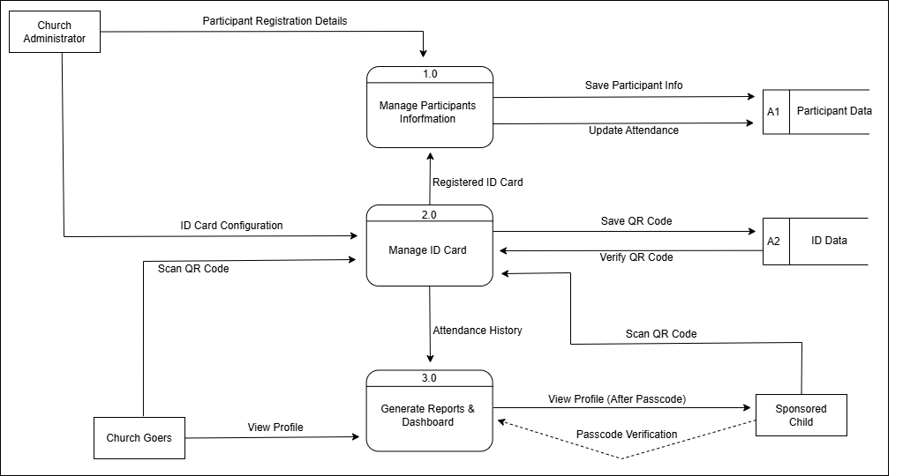
Figure 6. Data Flow Diagram
The Data Flow Diagram illustrates how data moves between external entities and the system processes, following the concept shown in the image with two main processes (2.0 Manage ID Card and Manage Participants Information) plus an additional process (3.0 Generate Reports & Dashboard) as the end flow. The external entities are: the Church Administrator (who manages participant registration, QR ID card assignment, and views reports), the Church Goer (who scans a QR code for attendance check-in and views their own attendance status), and the Sponsored Child (who scans a QR code for check-in and may view their own profile after passcode verification). Uses two encrypted data stores (AES 256): A1 Participant Data (Stores Participant profiles, including the Participant's name, age, whether they have a sponsor or not, and any updates to their growth) and A2 ID Data (Stores QR Code IDs, card assignments, and encrypted Unique IDs). Process 1.0 (Manage Participant Information) will take Participant Registration Details (name, age, and program) from the Church Administrator, store the data in A1, and then return a Registration Confirmation. Process 2.0 (Manage ID Card) will take the ID Card Configuration from the Administrator, read the data from A1 to correctly associate a QR code with the relevant Participant, store the QR Code Assignment in A2, and then output ID Records to the Administrator. It will then receive a QR Code Scan from either a Church Goer or a Sponsored Child, verify the encrypted ID against that in A2, and output the Registered ID Card to process 1.0 and register attendance automatically. Process 3.0 (Generate Reports & Dashboard - the end flow) will receive the Attendance History, the Participant profiles from A1, and the risk scores and forecast from the Predictive Analytics Module, then outputs to the Church Administrator (real time participation dashboard, list of at risk children, and system audit logs) and output to the Church Goer and Sponsored Child (view profile - only non-sensitive data for the Church Goer; the sponsored child profile will be unlocked after they enter the password). Following QR code scanning and attendance recording, A1 is automatically updated, and Process 3.0 is automatically executed. In Process 3.0, an attendance confirmation is shown on screen for the Church Goer. The Sponsored Child can access their profile after entering a password (with sponsor information, past donations, and child updates and letters). A dashboard is available to the Church Administrator, including predictive data, all audit logs, and report options; there is also a notification and display to a churchgoer when attendance has been registered. All data flows between processes, external entities, and data stores are protected by TLS 1.3 (in transit) and AES-256 (at rest), and role-based access control (RBAC) ensures that only authorized users receive specific outputs.
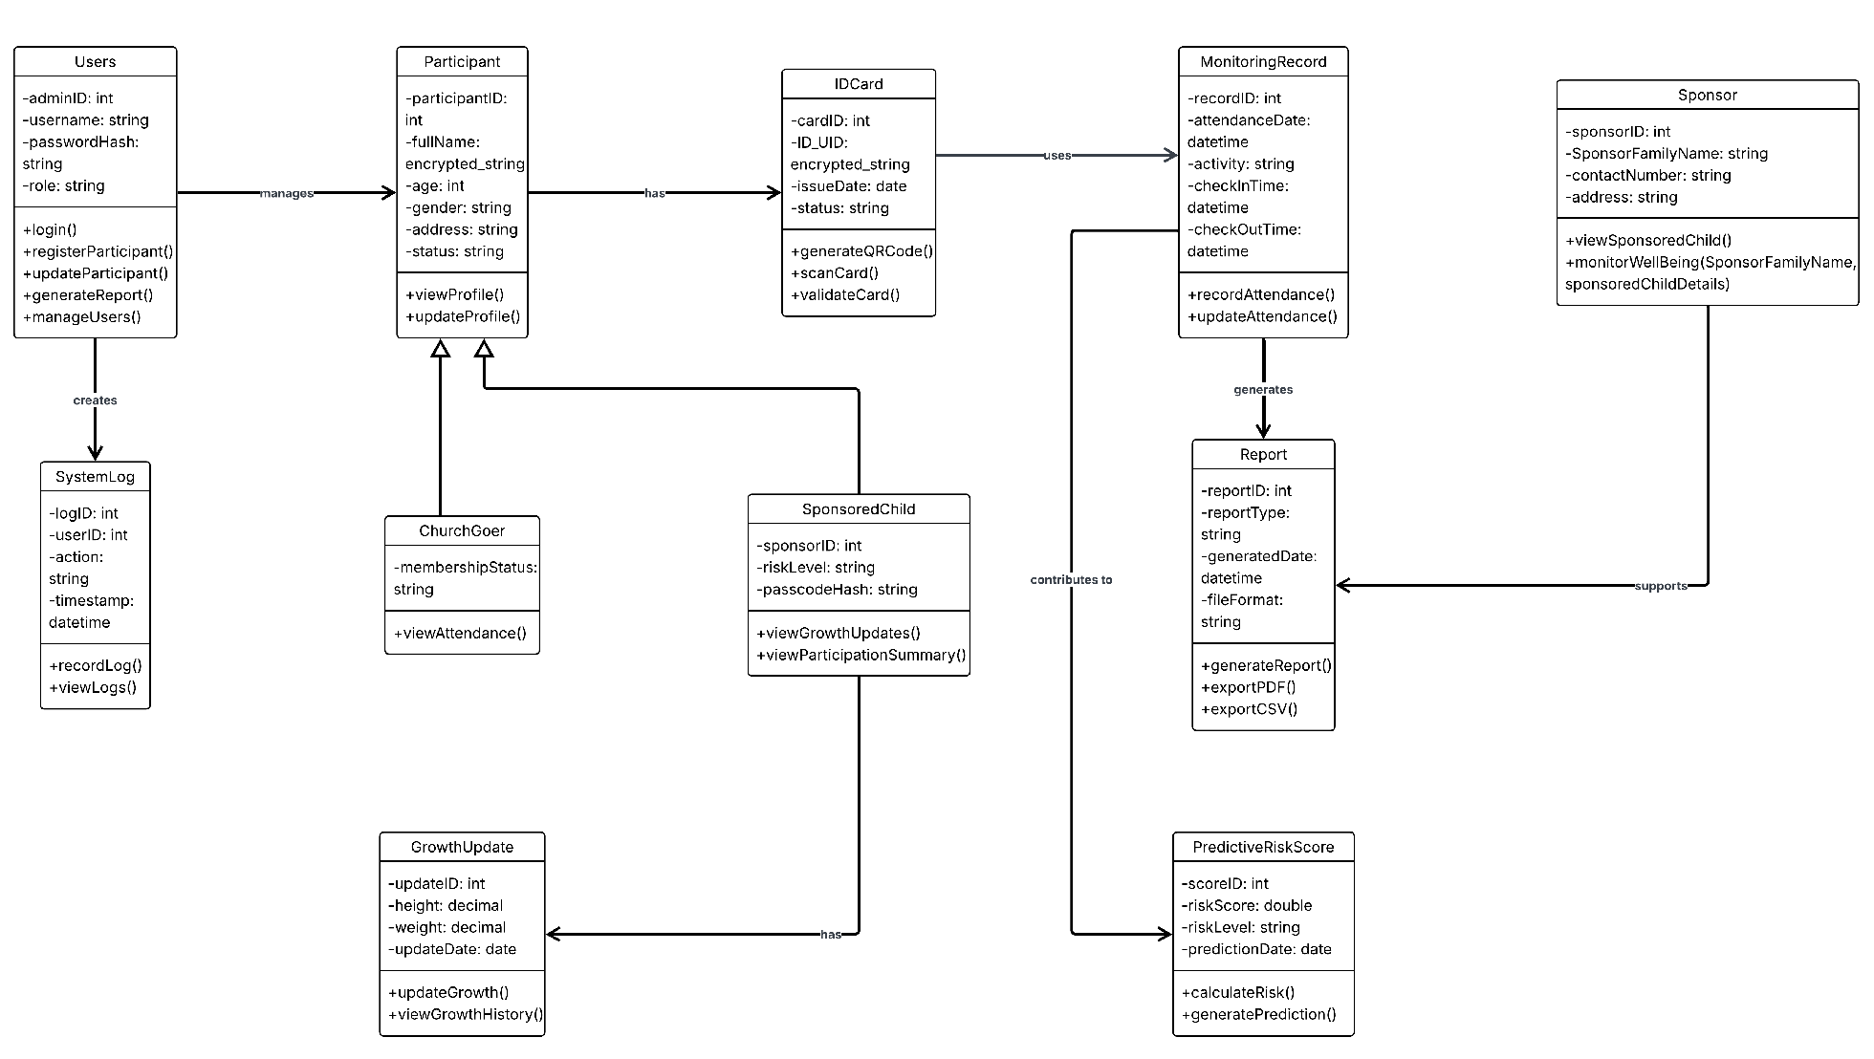
Figure 7. Class Diagram
The Web-Based Monitoring System for Sponsored Children and Churchgoers with Predictive Participation Analytics includes several related classes, each responsible for tracking participants, QR code-based check-in, sponsored child attendance management, and the system's security. At the center of this system is the Administrator class, which stores Login credentials (adminID, username, password, encrypted using the Bcrypt algorithm, not plain text) and is responsible for the system's overall activities (RBAC). All persons who attend church (Sponsored child and churchgoer) belong to the Participant class, which stores their details (participantID, fullname, age), with PII encrypted using AES-256.
Every Participant is associated with one IDCard class, which contains the Card ID and the ID_UID (uniquely encrypted). IDCard Class includes a method to perform automated QR code check-in/check-out using the scanCard method (cardID, DateDate, activity), saving each Participant’s attendance history in a new object of the Monitoring Record class. Encrypted data is stored in the Database. The child is further associated with the Sponsor class, which shows the sponsored child's family name (SponsorFamilyName), and provides methods to check the sponsored child's attendance and well-being (SponsorFamilyName, sponsoredChildDetails) based on RBAC. The details such as Height and weight of Sponsored Child will be recorded using GrowthUpdate class (updateID, Height, weight) using updateGrowth() method; the church member can store each record using the class, and Report of the sponsored child and church goer is generated from the Database and is saved using generateReport() method and provides the encrypted summary with choice for PDF/CSV export for church administrator and sponsors. In contrast, all data is stored with level-3 encryption. Classes are related using the following: - (Administrator)-manage- (Participant), - (MonitoringRecord)-generate- (Report), - (Sponsor)-supports- (Report), - (IDCard)-use- (MonitoringRecord)
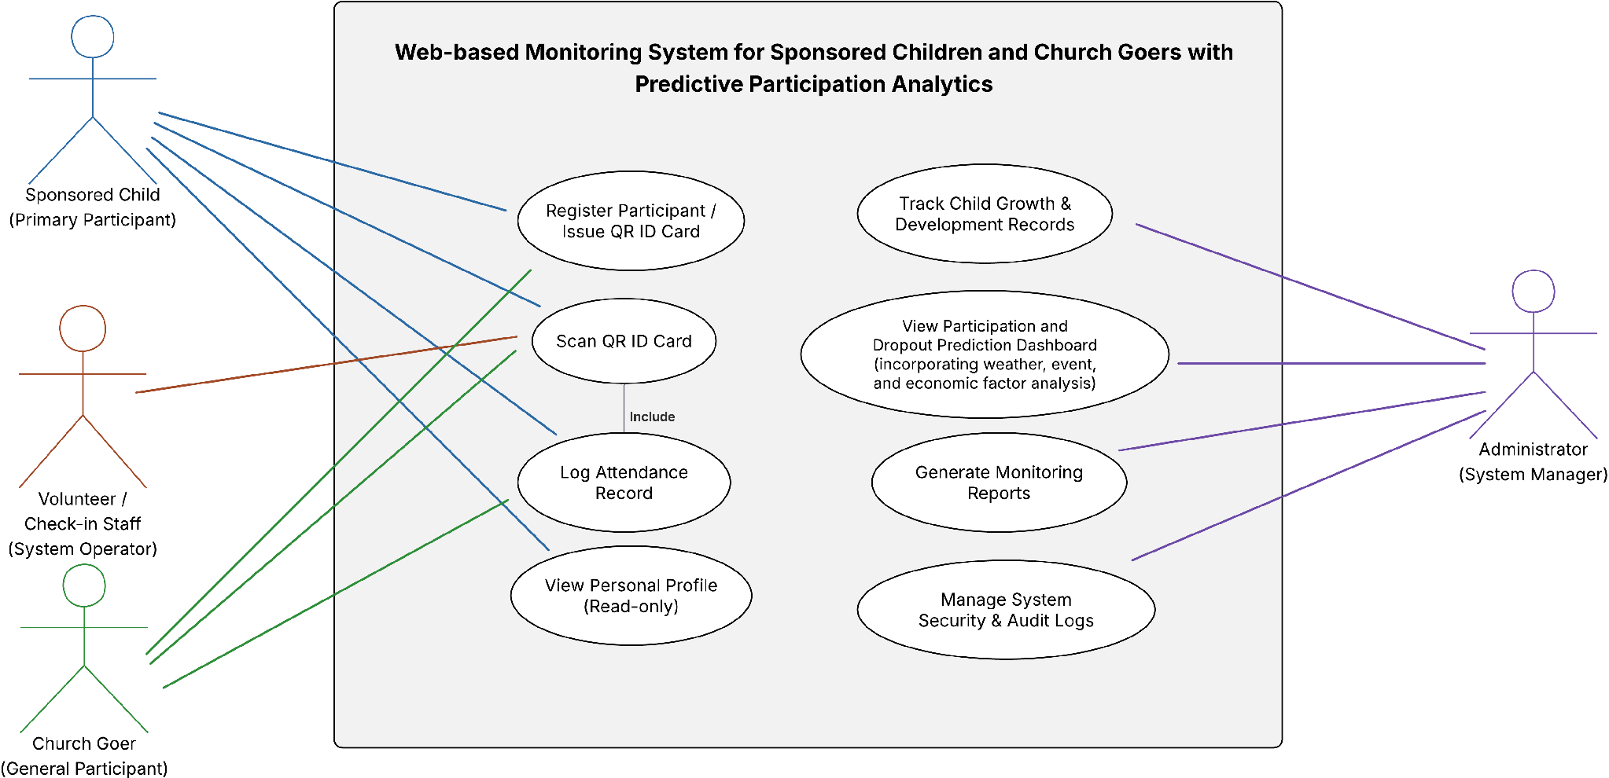
Figure 8. Use Case Diagram
The Use Case Diagram of the Web-Based Monitoring System for Sponsored Children and Church Goers with Predictive Participation Analytics describes the roles of the Administrator, Church Goer, and Sponsored Child, as well as the system's functionalities. It shows the interactions they have with the system for participant data, attendance monitoring and analysis, report generation, participant status, and child growth tracking using a QR-based system. The Login uses a TLS 1.3 to allow secured access for the users using the encrypted credentials, Register Participants to store participant's information in a AES-256 encrypted database (Church Goer and Sponsored Children's data) and to enroll and record their information for them to be used on attendance tracking by means of linking the unique encrypted QR code and/or ID on them for efficient automated scanning for their attendance, and the Manage Participant Records to update and maintain existing data on participants. The Administrator is also given the functionality to view monitoring reports, which are optional for generating attendance summaries and for reporting and evaluation purposes, and can be exported with encryption.
Scan ID (QR scan): the system's capability to read QR codes from ID Cards for automatic attendance. Church Goers and Sponsored Child are the actors in this case. View Participants' Status: The Administrator can view each Participant's participation status. View Growth Updates: The Administrator and sponsored child would be able to see the development progress of sponsored children, depending on their access role defined by the RBAC and Report. Generally, the Use case diagram clearly shows how the Admin, Church Goers, and Sponsored Child use the system to perform registration, QR scanning, attendance monitoring, viewing participation status and growth updates, and reporting. All the sensitive data will be protected with Level 3 Encryption: AES-256 at rest and TLS1.3 at transit

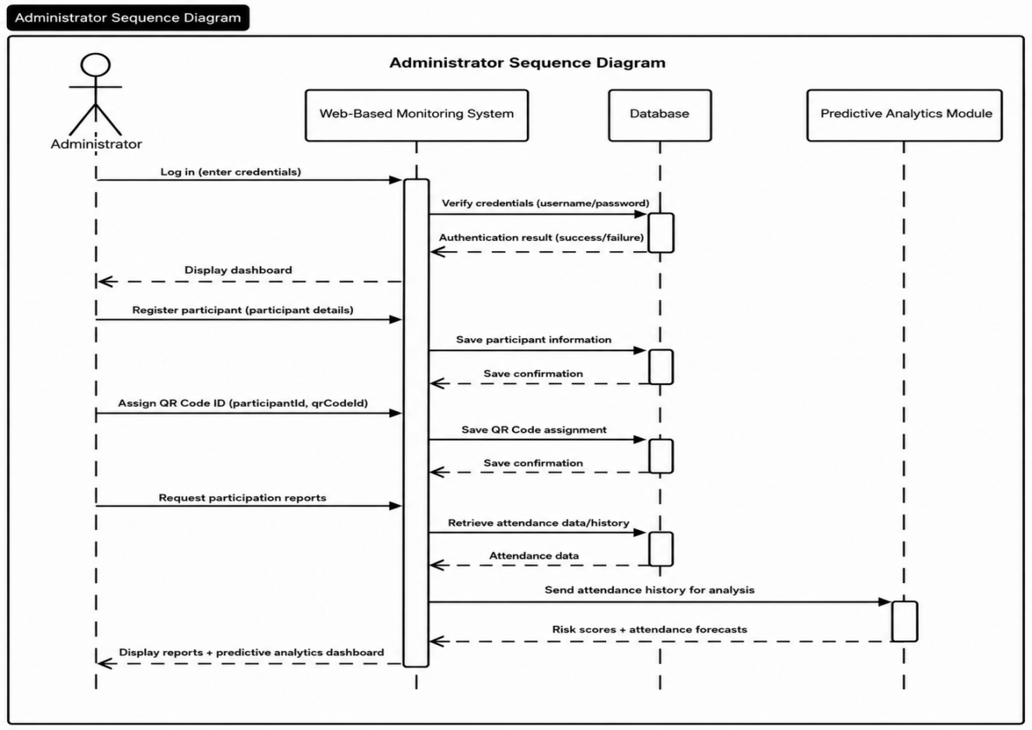

Figure 9. Administrator Sequence Diagram
The Administrator Sequence Diagram shows a step-by-step interaction among the Church Administrator, Web-Based Monitoring System, Database, and Predictive Analytics Module to manage participants, issue a QR-based secure digital ID, and obtain a predictive report. The Administrator will have to log in to the system using a username and password. The Web-Based Monitoring System will validate the username and password against the Database and return an authentication result. If successfully logged in, the system will display the Administrator's dashboard. Then the Administrator registers a new participant by providing the Participant's details, which are saved to the Database. The system will notify the Administrator whether the data has been saved to the Database. Then the Administrator will provide the Participant with a participant ID and a unique QR code, which will be assigned to the Participant and saved in the Database. Each ParticipantParticipant receives a security ID (QR Card) to check in and out of the place easily. Finally, the Administrator will query the participation report via the Web-Based Monitoring system. The Web-Based Monitoring system will retrieve all attendance history from the Database and pass it to the predictive analytical module, so that, using an ML-based algorithm, it will compute the risk scores and predict the future attendance pattern of participants to the Administrator, which will help the Church Administration to identify children with a higher probability of dropping out in the future. All data sent to or received from the system is encrypted using TLS 1.3. All data in the Database is encrypted using AES-256 and can be accessed only by logged-in users with a specific role.

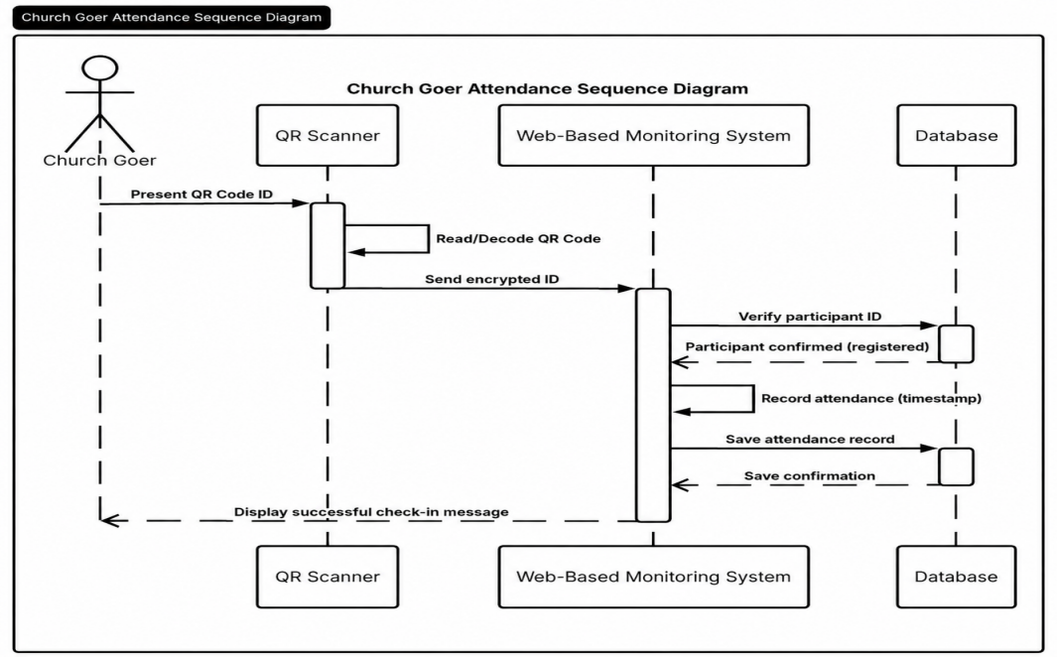
Figure 10. Church Goer Sequence Diagram
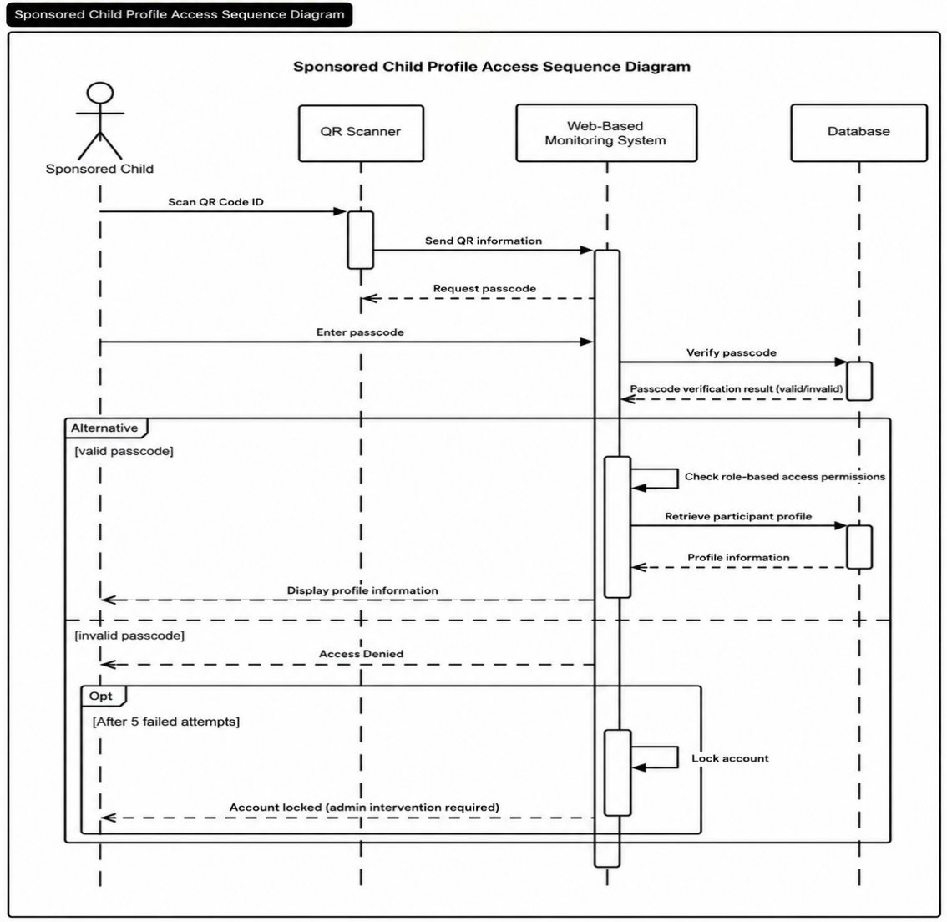
The Church Goer Sequence Diagram depicts a step-by-step flow of interactions among the Church Goer, QR Scanner, Web-Based Monitoring System, and the Database to automate contactless attendance tracking based on a QR-based secure digital identity. In the beginning, the churchgoer's QR Code ID Card (which stores the encrypted user identity) is presented to the QR Scanner. The QR Scanner reads and decodes the QR code to obtain the encrypted participant ID. To prevent eavesdropping, the encrypted participant ID is communicated to the Web-Based Monitoring System over TLS 1.3 (in transit). The system validates the participant ID against the Database upon reception of the encrypted participant ID. If the Database recognizes the participant ID, the system will respond with the Participant. Participant is validated (registered). Once the Participant is validated, attendance is logged by recording the current Date and time (check-in time) and the participant ID, and saving the record to the Database. A save confirmation is sent back by the Database, confirming successful attendance saving. The system will then display a successful check-in message to the Church Goer (or play a sound), thus completing the check-in process. It is anticipated that this sequence will take less than 2 seconds per scan. Data is secured in transit via TLS 1.3, and data at rest is also encrypted with AES-256. Users wishing to access this information will have their permissions set according to RBAC (role-based access control).

Figure 11. Sponsored Child Sequence Diagram
The Sponsored Child Profile Access Sequence Diagram outlines the sequence of actions the Sponsored Child, QR Scanner, Web-Based Monitoring System, and Database take to access sensitive personal data (sponsor, medical data, donation history) for a Sponsored Child. 2 levels protect access to the sensitive data. It is not used for simply checking in to a service (in this scenario). To meet Level 3 data protection requirements, a QR scan and a passcode are required. The Sponsored Child presents their QR Code ID card to the QR Scanner, which scans/decodes the QR code and sends the encrypted QR data over TLS 1.3 (in transit) to the Web-Based Monitoring System. The Web-Based Monitoring System receives the QR code and then presents the Sponsored Child with a login screen to enter their passcode (the only people who know the passcode are the Sponsored Child and the child's guardian) and verify their identity with the Web-Based Monitoring System. The login system sends the passcode to the Database to compare it with the hashed (bcrypt) passcode. If the passcode is correct, the Web-Based Monitoring System first checks RBAC for the Sponsored Child role, and the Database verifies that the appropriate RBAC is valid. It retrieves the participant profile and all associated data from the Database, returns the profile data to the Web-Based Monitoring System, and displays the sponsored child's profile on the screen. If the passcode does not match, then the system will display "Access Denied" and increment the fail counter for that user. After 5 consecutive failed entries (shown as an alternative flow in the diagram), the system will issue a command to the Database to lock the account. The Database will confirm that the account has been locked and then will provide "Account locked-admin intervention required." An administrator (Church Admin or System Admin) must manually unlock the account. All sensitive data (personally identifiable data for minors, sponsor records, medical data) will be stored within the Database using AES-256 encryption (data at rest), and all data transferred between the system and the device/Database will be secured using TLS 1.3 encryption (data in transit). Raw passcodes will never be stored in the system; only the hashed version will be saved in the Database. By using a multi-layer security process (QR code + passcode + RBAC + encryption), even if the QR code is stolen and compromised, there is still protection. + encryption) there is even if the QR code is stolen and then compromised.

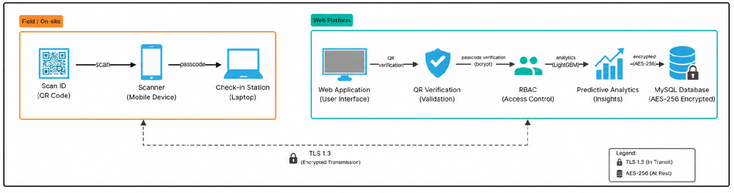
Development Phase
Figure 12. System Architecture
The architecture is divided into 2 environments: Field/On-site and Web Platform. In the Field/On-site environment, a user provides a Scan ID (QR Code) and is scanned using a mobile device or QR code reader. The QR Code contains a unique identifier (UID), which is then transmitted along with a passcode through the check-in station (laptop) as a preliminary step in collecting user identification information.
The Web Platform includes a Web Application (UI) in which QR and passcode verification are performed using bcrypt for secure authentication. When the system has verified this, it checks access via Role-Based Access Control (RBAC). If valid, the data from attendance and monitoring can be used for predictive analytics with LightGBM to generate results, all stored in a MySQL database. This data is also encrypted in transit using TLS 1.3 and AES-256, and at rest, it is accessed by church admins via a dashboard.
.

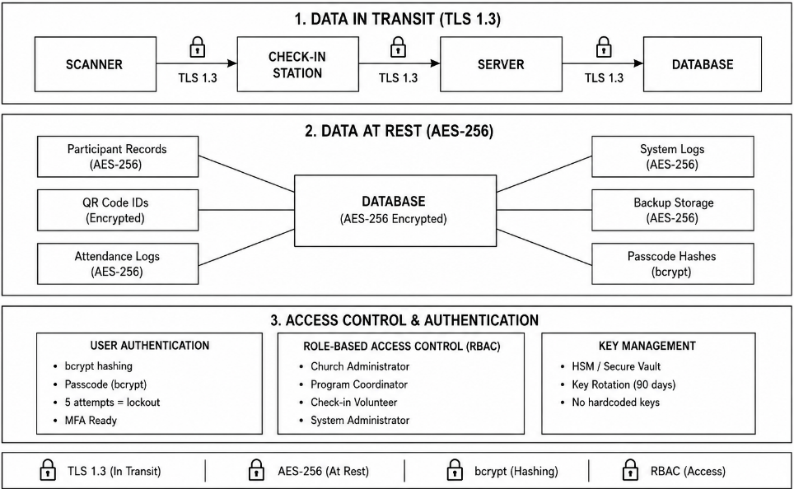

Figure 13. Level 3 Encryption Architecture
At Level 3 Encryption, there are three security levels. Data in transit - the entire flow of data from/to Scanner, Check-in station, server, Database is encrypted with TLS 1.3. Data at rest - the participant record, QR Code IDs, attendance logs, system logs, and system backup files are encrypted using AES-256. At the same time, because the Database is configured this way, user passcodes will be encrypted with bcrypt. Access control & Authentication - Users will be authenticated using bcrypt, with a limit of 5 login attempts and the option to enable MFA. Four types of RBAC will be set. All keys are stored and managed in the HSM, and key rotation will occur every 90 days.

References
Abukader, A., Alzubi, A., & Adegboye, O. R. (2025). Intelligent System for Student Performance Prediction: An Educational Data Mining Approach Using Metaheuristic-Optimized LightGBM with SHAP-Based Learning Analytics. Applied Sciences (Switzerland), 15(20). https://doi.org/10.3390/app152010875
Adjin-Tettey, T. D., & Kwofie, J. (2025). Digital sanctuary: exploring security and privacy concerns of congregants in the virtual church. Atlantic Journal of Communication, 33(2), 341–356. https://doi.org/10.1080/15456870.2024.2397965
Akoh Atadoga, Oluwatoyin Ajoke Farayola, Benjamin Samson Ayinla, Olukunle Oladipupo Amoo, Temitayo Oluwaseun Abrahams, & Femi Osasona. (2024). A COMPARATIVE REVIEW OF DATA ENCRYPTION METHODS IN THE USA AND EUROPE. Computer Science & IT Research Journal, 5(2), 447–460. https://doi.org/10.51594/csitrj.v5i2.815
Benique, C. O. T. (2025). School Attendance Control System Based on RFID Technology with Raspberry Pi and Arduino: EDURFID. http://arxiv.org/abs/2507.14191
Bhatt, D. P., Bhatnagar, V., Sharma, A., & Ledwani, D. (2024). School children safety system using RFID and IoT. https://doi.org/10.1063/5.0221527
Campbell, H. A. (2023). When Churches Discovered the Digital Divide: Overcoming Technological Inaccessibility, Hesitancy & Digital Reluctance During the covid-19 Pandemic. Ecclesial Practices, 10(1), 36–61. https://doi.org/10.1163/22144417-bja10046
Ricoh Asia. (2023). Catholic Archdiocese of Perth Transforms Massive Data Archives with Ricoh.
Joy Awad. (2023). Event Attendance Prediction and Recommendation System: A Comparative Study of Machine Learning Algorithms.
Ishaq, K., & Bibi, S. (n.d.). IoT BASED SMART ATTENDANCE SYSTEM USING RFID: A SYSTEMATIC LITRATURE REVIEW.
Kaell, H. (2022). The long history of child sponsorship, c.1700-1950. Historical Research, 95(267), 45–61. https://doi.org/10.1093/hisres/htab031
Kishore Gudepu, B., & Sai Jaladi, D. (2022). Data Discovery and Security: Protecting Sensitive Information. In INTERNATIONAL JOURNAL OF ACTA INFORMATICA.
Kusuma, A. A., & Utami, W. S. (2025). Pengembangan Aplikasi Web dan Mobile dengan Fitur QR Code untuk Pembayaran dan Donasi Digital di Gereja. Jurnal Informatika Ekonomi Bisnis, 1–6. https://doi.org/10.37034/infeb.v8i1.1333
Lerner, A. (2017). Measuring and Improving Security and Privacy on the Web: Case Studies with QR Codes, Third-Party Tracking, and Archives.
Lhouel Canoy Retobes, D., Luveille Baynosa, M. T., Von Guillano, D., & Soberano, K. T. (2025). Enhancing Data Management Efficiency through Effective File Archiving Systems at Old Town Church. Journal Homepage GAS Journal of Engineering and Technology (GASJET), 2(2), 52–61. https://doi.org/10.5281/zenodo.15432600
Mahlan, S. B., Othman, J., Shamsuddin, M., Adilah, S., Yusoff, M., & Othman, Z. (2025). A Web-Based System for Managing Student Attendance and Assessment Submissions: An SDLC Waterfall Model Approach ARTICLE INFO ABSTRACT. Journal of Computing Research and Innovation, 10(2), 2025. https://doi.org/10.24191/jcrinn.v10i2.539
Matasio, J. F. (2017). RECORDS MANAGEMENT IN FRIENDS CHURCH (QUAKERS) IN KENYA.
Mubeen, M., Arslan, M., & Anandhi, G. (2022). Strategies to Avoid Illegal Data Access. 12. https://doi.org/10.37591/JoCES
NIST.CSWP. (2024). The NIST Cybersecurity Framework (CSF) 2.0. https://doi.org/10.6028/NIST.CSWP.29
Eunice Karambu Makathimo. (2022). THE METHODIST CHURCH IN KENYA’S SPONSORSHIP PROGRAMME ON ORPHANS: A RE-EXAMINATION OF THE EFFECTIVENESS OF ITS MATERIAL AND SPIRITUAL NEEDS, WITH REFERENCE TO THE DAY SECONDARY SCHOOL IN IMENTI NORTH, MERU COUNTY EUNICE KARAMBU MAKATHIMO A THESIS SUBMITTED IN PARTIAL FULFILLMENT FOR THE REQUIREMENTS OF THE DOCTOR OF PHILOSOPHY DEGREE (RELIGIOUS STUDIES) AT THE KENYA METHODIST UNIVERSITY.
S, S., Anjum, S., C, S., R, A., & R, D. (2026). Automated Child Health Monitoring System. International Journal of Creative and Open Research in Engineering and Management, 02, 1–9. https://doi.org/10.55041/ijcope.v2i6.026
NIST.SP. (2020). Security and Privacy Controls for Information Systems and Organizations. https://doi.org/10.6028/NIST.SP.800-53r5
Simanjuntak, A. G., & Porman Malau, E. (2026). Journal of Artificial Intelligence and Engineering Applications Web-Based Inventory Management Information System for Catholic Church (Vol. 5, Number 2). https://ioinformatic.org/
Song, S., Kim, J., Kang, B., Park, W., & Kim, J. (2018). BebeCODE: Collaborative child development tracking system. Conference on Human Factors in Computing Systems - Proceedings, 2018-April. https://doi.org/10.1145/3173574.3174114
Suhardi, S. (2024). Use of QRCode and Digital Signature Using The DSA Method to Authenticate Student Academic Documents. Journal of Computer Networks, Architecture and High Performance Computing, 6(4), 1913–1921. https://doi.org/10.47709/cnahpc.v6i4.4765
Teologice, O., Bogdan, A., & Bogdan Andrei, A. (2026). Title: Citation style: The joined archive of hundreds of Central-, East-and South-East-European publishers, research institutes, and various content providers You have downloaded a document from The Church’s Mission in the Digital Age: Challenges and Opportunities.
Brad Watson. (n.d.). Watson__B._3_chapter.
Wiratama, J., & Desanti, R. I. (2021). Analysis and Design of Web-Based Information System for Church Congregations Case Study: Church BNKP Pewarta. Ultima Infosys : Jurnal Ilmu Sistem Informasi, 12(2), 115.

APPENDICES

Appendix A

CURRICULUM VITAE


Personal Background:

Name : Lawrence M. Cuano
Nickname : Renz
Date of Birth : February 26, 2004
Sex : Male
Place of Birth : Poblacion, Bayugan City
Home Address : P-10 A Kamatsili St.
Poblacion, Bayugan City
Citizenships : Filipino
Name of Father : Paulo B. Cuano
Name of Mother : Vergie M. Cuano

Educational Attainment:

Elementary : Bayugan Central Elementary School
SPED Center (BCESSC)
Secondary : Bayugan National Comprehensive
High School (BNCHS)
Tertiary : Agusan del Sur State University

Membership to Organization: CCIS

CURRICULUM VITAE



Personal Background:

Name : Z Kyrk P. Lunas
Nickname : Kurt
Date of Birth : June 7, 2004
Sex : Female
Place of Birth : Bunawan,
Agusan del Sur
Home Address : P-9 Pulang-Lupa,
Trento,
Agusan del Sur
Citizenships : Filipino
Name of Father : Jun Rey P. Lunas
Name of Mother : Miralyn P. Lunas
Name of Brother : Yuan Rey P. Lunas
Name of Sister : Xyza Lorrainne P. Lunas

Educational Attainment:

Elementary : Trento Central Elementary Schoool
Secondary : Trento National High School
Tertiary : Agusan del Sur State University

Membership to Organization: CCIS

Appendix B

GANTT CHART

Table 23. Timeline View
 | March | April | May | June
Title Proposal
Approved Title
Preparing for Outline Defense
Outline Defense
Documentation
Processing for Softbound

Appendix C

COLLEGE RESEARCH FORM 6

Figure 14. CRF of Lawrence M. Cuano

Figure 15. CRF of Z Kyrk P. Lunas

Appendix D

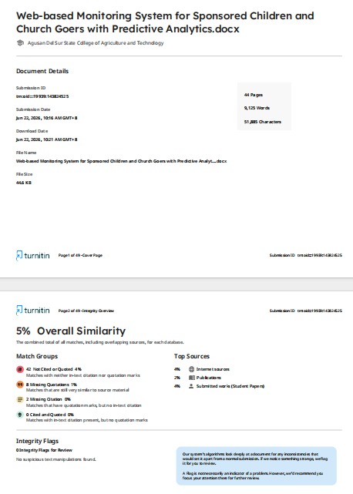
PLAGIARISM RESULT

Figure 16. Plagiarism Result Using Turnitin

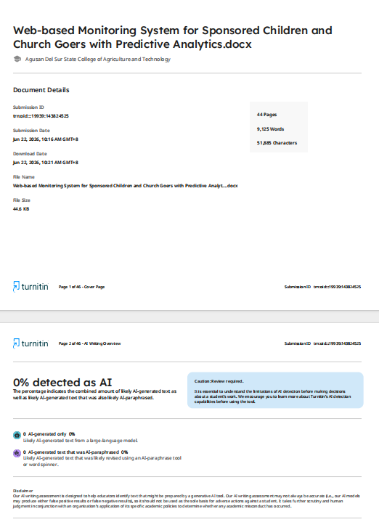
Figure 17. AI Result Using Turnitin

Appendix E

Grammarly Result

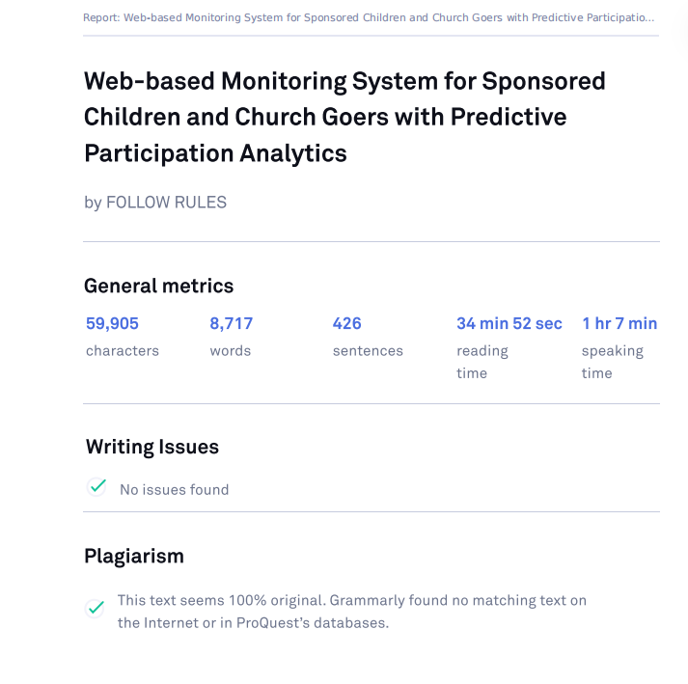

Figure 18. Grammarly Result

